MODULE I

INTRODUCTION TO PARALLEL PROCESSING
1.1 Introduction to parallel processing

Computing Generations
Computing is normally thought of as being divided into generations.Each successive generation is marked by sharp changes in hardware and software technologies. With some exceptions, most of the advances introduced in one generation are carried through
to later generations. We are currently in the fifth generation.

First Generation (1945 to 1954)
Technology and Architecture:
- Vacuum tubes and relay memories
- CPU driven by a program counter (PC) and accumulator
- Machines had only fixed-point arithmetic
- Software and Applications
- Machine and assembly language
- Single user at a time
- No subroutine linkage mechanisms
- Programmed I/O required continuous use of CPU
Representative systems:
- ENIAC, Princeton IAS,IBM 701

Second Generation (1955 to 1964)
Technology and Architecture:
- Discrete transistors and core memories
- I/O processors, multiplexed memory access
- Floating-point arithmetic available
- Register Transfer Language (RTL) developed
- Software and Applications
High-level languages (HLL):
- FORTRAN, COBOL, ALGOL with compilers and subroutine libraries
- Still mostly single user at a time, but in batch mode
Representative systems:
- CDC 1604, UNIVAC LARC, IBM 7090

Third Generation (1965 to 1974)
Technology and Architecture:
- Integrated circuits (SSI/MSI)
- Microprogramming
- Pipelining, cache memories, lookahead processing
- Software and Applications
- Multiprogramming and time-sharing operating systems
- Multi-user applications
Representative systems:
- IBM 360/370, CDC 6600, TI ASC, DEC PDP-82

Fourth Generation (1975 to 1990)
Technology and Architecture:
- LSI/VLSI circuits, semiconductor memory
- Multiprocessors, vector supercomputers, multicomputers
- Shared or distributed memory
- Vector processors
- Software and Applications
- Multprocessor operating systems, languages, compilers, and parallel software tools
Representative systems:
- VAX 9000, Cray X-MP, IBM 3090, BBN TC2000

Fifth Generation (1990 to present)
Technology and Architecture:
- ULSI/VHSIC processors, memory, and switches
- High-density packaging
- Scalable architecture
- Vector processors
- Software and Applications
- Massively parallel processing
- Grand challenge applications
- Heterogenous processing
Representative systems:
- Fujitsu VPP500, Cray MPP, TMC CM-5, Intel Paragon

Von Neumann Architecture
All computers share the same basic architecture, whether it be a multi-million dollar mainframe or a Palm Pilot. All have memory, an I/O system, and arithmetic/logic unit, and a control unit. This type of architecture is named Von Neumann architecture after the
mathematician who conceived of the design.
Memory
Computer Memory is that subsystem that serves as temporary storage for all program
instructions and data that are being executed by the computer. It is typically called RAM. Memory is divided up into cells, each cell having a unique address so that the data can be fetched.
Input / Output
This is the subsystem that allows the computer to interact with other devices and communicate to the outside world. It also is responsible for program storage, such as hard drive control. Again, I discuss this in other sections of the site in more detail, so I will not address it again here.
Arithmetic/Logic Unit
This is that subsystem that performs all arithmetic operations and comparisons for equality. In the Von Neumann design, this and the Control Unit are separate components, but in modern systems they are integrated into the processor. The ALU has 3 sections, the
register, the ALU circuitry, and the pathways in between.
The register is basically a storage cell that works like RAM and holds the results of the calculations. It is mush faster than RAM and is addresses differently. The ALU circuitry is that actually performs the calculations. and it is designed from AND, OR, and NOT gates just as any chip. The pathways in between are self-explanatory - pathways for electrical current within the ALU.
Control Unit
The control unit has the responsibility of (1) fetching from memory the next program
instruction to be run, (2) decode it to determine what needs to be done, then (3) issue the proper command to the ALU, memory and I/O controllers to get the job done. These steps are done continuously until the last line of a program is done, which is usually QUIT or STOP.

Parallel Computing
Traditionally, software has been written for serial computation:
  - To be run on a single computer having a single Central Processing Unit (CPU);
  - A problem is broken into a discrete series of instructions.
  - Instructions are executed one after another.
  - Only one instruction may execute at any moment in time.
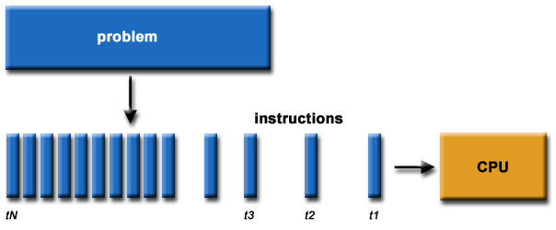
- In the simplest sense, parallel computing is the simultaneous use of multiple compute resources to solve a computational problem.
  - To be run using multiple CPUs
  - A problem is broken into discrete parts that can be solved concurrently
  - Each part is further broken down to a series of instructions
  - Instructions from each part execute simultaneously on different CPUs
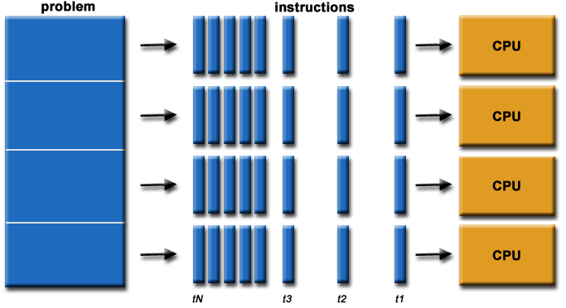
- The compute resources can include:
  - A single computer with multiple processors;
  - An arbitrary number of computers connected by a network;
  - A combination of both.
- The computational problem usually demonstrates characteristics such as the ability to be:
  - Broken apart into discrete pieces of work that can be solved simultaneously;
  - Execute multiple program instructions at any moment in time;
  - Solved in less time with multiple compute resources than with a single compute resource.
- Parallel computing is an evolution of serial computing that attempts to emulate what has always been the state of affairs in the natural world: many complex, interrelated events happening at the same time, yet within a sequence. Some examples:
  - Planetary orbits, galaxy formation
  - Weather and ocean patterns
  - Tectonic plate drift
  - Rush hour traffic in LA
  - Automobile assembly line
  - Daily operations within a business
  - Building a shopping mall
  - Ordering a hamburger at the drive through.
- Traditionally, parallel computing has been considered to be "the high end of computing" and has been motivated by numerical simulations of complex systems and "Grand Challenge Problems" such as:
  - weather and climate
  - chemical and nuclear reactions
  - biological, human genome
  - geological, seismic activity
  - mechanical devices - from prosthetics to spacecraft
  - electronic circuits
  - manufacturing processes
- Today, commercial applications are providing an equal or greater driving force in the development of faster computers. These applications require the processing of large amounts of data in sophisticated ways. Example applications include:
  - parallel databases, data mining
  - oil exploration
  - web search engines, web based business services
  - computer-aided diagnosis in medicine
  - management of national and multi-national corporations
  - advanced graphics and virtual reality, particularly in the entertainment industry
  - networked video and multi-media technologies
  - collaborative work environments
- Ultimately, parallel computing is an attempt to maximize the infinite but seemingly scarce commodity called time.
1.2 TRENDS TOWARDS PARALLEL PROCESSING

The usage of computer is having a trend of four levels of sophistication:-
-Data processing
-Information Processing
-Knowledge processing
-Intelligence processing

Data Space is the largest, including numeric numbers in various formats, character symbols and multi dimensional measures. Data objects are considered mutually unrelated in space.
An information item is a collection of data objects that are related by some syntactic structure or relation. Therefore information item forms a subspace of data space.
Knowledge consists of information items plus some semantic meaning. Thus knowledge space forms a subspace of information space.
Finally intelligence is derived from a collection of knowledge items.

Data Processing

Information Processing

Information Processing

Knowledge Processing

Intelligence
Processing

From an OS point of view, computer systems have improved chronologically in four phases.
-batch processing
-Multiprogramming
-time sharing
-multiprocessing

The highest level of parallel processing is conducted among multiple jobs or programs through multiprogramming, timesharing and multiprocessing. This level requires the development of parallel processable algorithms. The implementation of parallel algorithms depends on the efficient allocation of limited hardware software resources to multiple programs being used to solve a large computation problem.
The next highest level of parallel processing is conducted among procedures or tasks within the same program. This involves the decomposition of a program into multiple tasks.
The third level is to exploit concurrency among multiple instructions. Data dependency analysis is often performed to reveal parallelism among instructions.
The next level of parallelism is to have faster and concurrent operations within each instruction.
The highest level is often conducted algorithmically. The lowest is often implemented directly into the hardware. Hardware role increases from high to low. Software implementation increases from low to high.

1.3 PARALLELISM IN UNIPROCESSOR
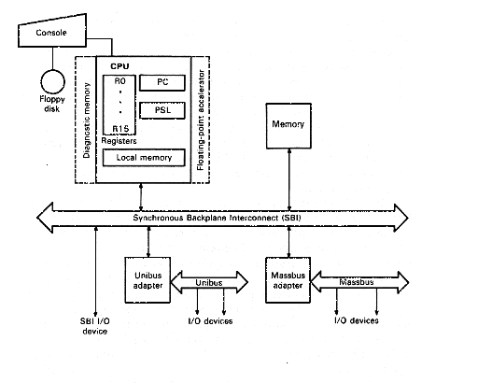
Figure: VAX 11/780 Organizational Architecture
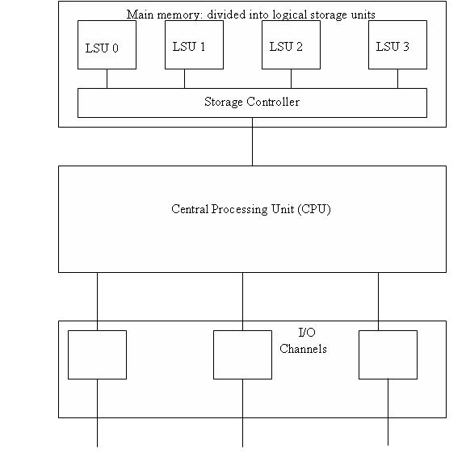

Figure : the system architecture of IBM 370/ model 198
Parallelism in uniprocessors can be achieved by the following six mechanism.
- Multiplicity of functional unit
- Parallelism and pipelining within the CPU
- Overlapped CPU and I/O operations
- Use of hierarchical memory systems
- Balancing of subsystem bandwidth
- Multiprogramming and timesharing

Multiplicity of functional unit
Parallel processing can be achieved in a uniprocessor system by using multiple functional units which can operate simultaneously. CDC 6600 is having 10 functional units for performing operations in parallel.

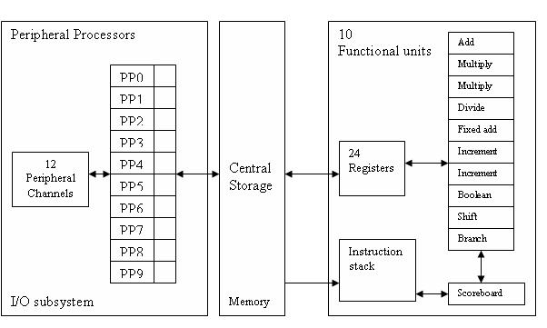
Figure : System architecture of CDC 6600

Parallelism and pipelining within the CPU
Parallel adders, look-ahead adders and carry save adders implemented in the CPU helps to achieve parallelism.
Instruction execution can be pipelined over many stages such as instruction fetch, decode, operand fetch, execute and write back which can perform the operations in an overlapped manner.

Overlapped CPU and I/O operations
I/O operations can be performed simultaneously with CPU operations by using separate I/O controllers, channels or I/O processors.

Use of hierarchical memory system
By using a hierarchical memory system we are able to bring the memory speed almost same as that of CPU.

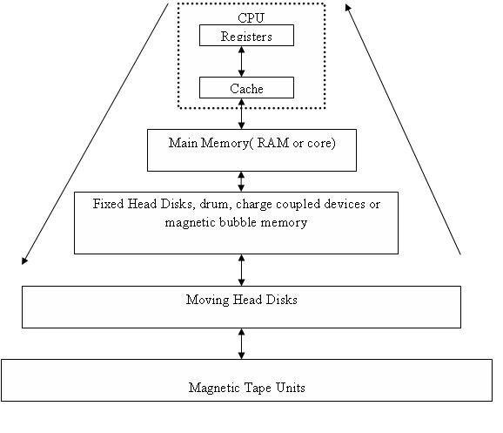
Balancing of subsystem bandwidth
In order to achieve parallelism we need to balance the bandwidth of CPU, Memory and I/O subsystems.
Speed gap between CPU and memory can be bridged using high speed cache memory.
Bandwidth balancing between memory and I/O can be balanced by using I/O channels.

Multiprogramming and time sharing
Both multiprogramming and time sharing help to achieve parallelism.

1.4 PARALLEL COMPUTER STRUCTURES
The parallel computer structures are

- Pipelined Computers
- Array processors
- Multiprocessor systems
- Data flow computers
- VLSI computing structures

1.4.1. Pipelined Computers

A pipeline computer is designed to perform overlapped computations, to exploit temporal parallelism. To achieve pipelining the input task must be subdivided into a sequence of subtasks, each of which can be executed by a specialized hardware stage that operates concurrently with other stages in the pipeline. Successive tasks are streamed into the pipe and get executed in a overlapped manner at subtask level.
Ideally all the processing stages in the pipeline should have equal processing speed. Otherwise, the slowest stage will become the bottleneck of the entire pipeline. Also the congestion caused by improper buffering may result in many idle stages waiting for results from the previous stage.
But in reality, successive stages in the pipeline have unequal delays. The optimal partition of the task depends on a number of factors including the efficiency of functional units, the desired processing speed and the cost effectiveness of the entire pipeline.

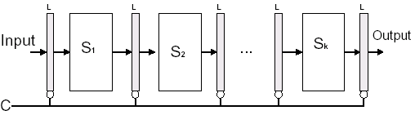

1.4.2. Array Processors
Performs computations on large arrays of data
- Attached array processor
Auxiliary processor attached to a general-purpose computer
- SIMD array processor
Manipulates vector instruction by using multiple functional units executing a common instruction
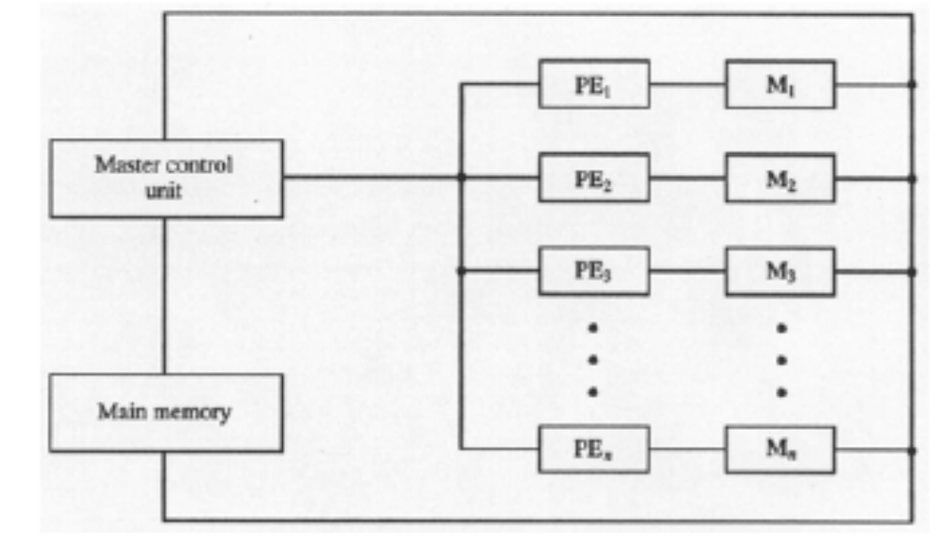
1.4.3. Multiprocessor System
A multiprocessor system is an interconnection of two or more CPU’s with memory and input-output equipment. The term "processor" in multiprocessor can mean either a central processing unit (CPU) or an input-output processor (IOP). However, a system with a single CPU and one or more IOP’s is usually not included in the definition of a multiprocessor system unless the IOP has computational facilities comparable to a CPU. As it is most commonly defined, a multiprocessor system implies the existence of multiple CPU’s, although usually there will be one or more IOP’s as well. Some multiprocessors can support operation in the presence of broken hardware; that is, if a single processor fails in a multiprocessor with n processors, the sistem provides continued service with n-1 processors. Multiprocessors may have the highest absolute performance__faster than the fastest uniprocessor. Multiprocessors are classified as multiple instruction stream, multiple data stream (MIMD) systems.
1.4.4. Dataflow Computers
Data flow computers are based on the concept of data-driven computation, which is drastically different from the operation of a conventional von Neumann machine. The fundamental difference is that instruction execution in a conventional computer is under program-flow control, whereas that in a data flow compute driven by the data (operand) availability.
1.4.5. VLSI Computational Structures
The rapid invent of very-large-scale-integrated technology has created a new architectural horizon in implementing parallel algorithms directly in hardware. The use of VLSI technology in high performance multiprocessors and pipelined- computing device is currently under intensive investigation in both industrial and research areas.

1.5ARCHITECTURE CLASSIFICATION SCHEMES

1.5.1 Flynn’s classification

There are different ways to classify parallel computers. One of the more widely used classifications, in use since 1966, is called Flynn's Taxonomy.
Flynn's taxonomy distinguishes multi-processor computer architectures according to how they can be classified along the two independent dimensions of Instruction and Data. Each of these dimensions can have only one of two possible states: Single or Multiple.
The matrix below defines the 4 possible classifications according to Flynn

S I S D  Single Instruction, Single Data | S I M D  Single Instruction, Multiple Data
M I S D  Multiple Instruction, Single Data | M I M D  Multiple Instruction, Multiple Data

Single Instruction, Single Data (SISD):
- A serial (non-parallel) computer
- Single instruction: only one instruction stream is being acted on by the CPU during any one clock cycle
- Single data: only one data stream is being used as input during any one clock cycle
- Deterministic execution
- This is the oldest and until recently, the most prevalent form of computer
- Examples: most PCs, single CPU workstations and mainframes
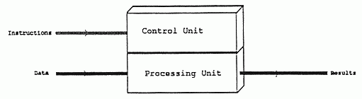
Flynn's SISD Architecture
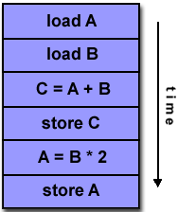

Single Instruction, Multiple Data (SIMD):
- A type of parallel computer
- Single instruction: All processing units execute the same instruction at any given clock cycle
- Multiple data: Each processing unit can operate on a different data element
- This type of machine typically has an instruction dispatcher, a very high-bandwidth internal network, and a very large array of very small-capacity instruction units.
- Best suited for specialized problems characterized by a high degree of regularity,such as image processing.
- Synchronous (lockstep) and deterministic execution
- Two varieties: Processor Arrays and Vector Pipelines
- Examples:
  - Processor Arrays: Connection Machine CM-2, Maspar MP-1, MP-2
  - Vector Pipelines: IBM 9000, Cray C90, Fujitsu VP, NEC SX-2, Hitachi S820
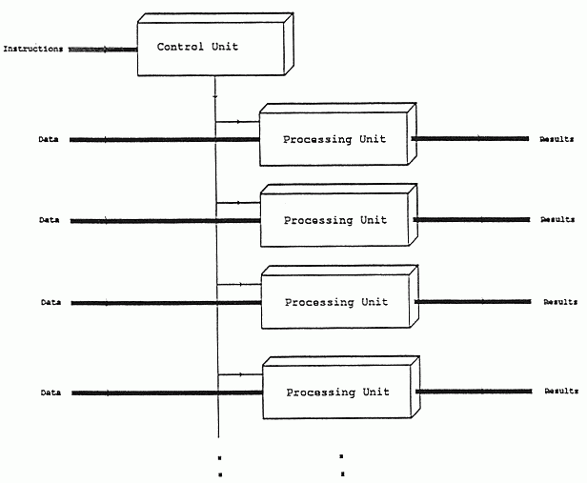
Flynn's SIMD Architecture
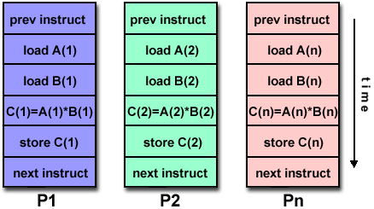

Multiple Instruction, Single Data (MISD):
- A single data stream is fed into multiple processing units.
- Each processing unit operates on the data independently via independent instruction streams.
- Few actual examples of this class of parallel computer have ever existed. One is the experimental Carnegie-Mellon C.mmp computer (1971).
- Some conceivable uses might be:
  - multiple frequency filters operating on a single signal stream
  - multiple cryptography algorithms attempting to crack a single coded message.

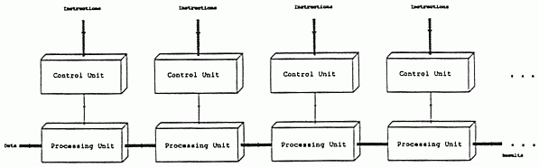

Flynn's MISD Architecture
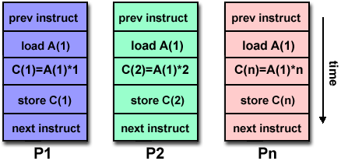

Multiple Instruction, Multiple Data (MIMD):

- Currently, the most common type of parallel computer. Most modern computers fall into this category.
- Multiple Instruction: every processor may be executing a different instruction stream
- Multiple Data: every processor may be working with a different data stream
- Execution can be synchronous or asynchronous, deterministic or non-deterministic
- Examples: most current supercomputers, networked parallel computer "grids" and multi-processor SMP computers - including some types of PCs.
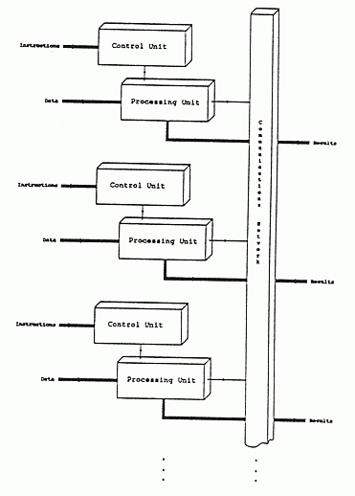
Flynn's MIMD Architecture

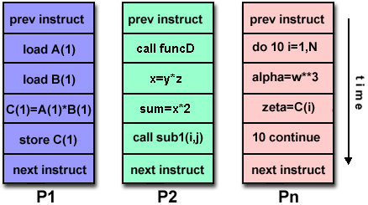

1.5.2 Handler’s Classification
In 1977 Handler proposed an elaborate notation for expressing the pipelining and parallelism of computers. Handler's taxonomy[2] addresses the computer at three distinct levels: the processor control unit (PCU), the arithmetic logic unit (ALU), and the bit-level circuit (BLC). The PCU corresponds to a processor or CPU, the ALU corresponds to a functional unit or a processing element in an array processor, and the BLC corresponds to a the logic needed to perform one-bit operations in the ALU.
Handler's taxonomy uses three pairs of integers to describe a computer:
Computer = (k * k', d * d', w * w')

Where k = number of PCUs
Where k'= number of PCUs that can be pipelined
Where d = number of ALUs controlled by each PCU
Where d'= number of ALUs that can be pipelined
Where w = number of bits in ALU or processing element (PE) word
Where w'= number of pipeline segments on all ALUs or in a single PE
The following rules and operators are used to show the relationship between various elements of the computer. The '*' operator is used to indicate that the units are pipelined or macro-pipelined with a stream of data running through all the units. The '+' operator is used to indicate that the units are not pipelined but work on independent streams of data. The 'v' operator is used to indicate that the computer hardware can work in one of several modes. The '~' symbol is used to indicate a range of values for any one of the parameters. Peripheral processors are shown before the main processor using another three pairs of integers. If the value of the second element of any pair is 1, it may omitted for brevity. Handler's taxonomy is best explained by showing how the rules and operators are used to classify several machines.
The CDC 6600 has a single main processor supported by 10 I/O processors. One control units coordinates one ALU with a 60-bit word length. The ALU has 10 functional units which can be formed into a pipeline. The 10 peripheral I/O processors may work in parallel with each other and with the CPU. Each I/O processor contains one 12-bit ALU. The description for the 10 I/O processors is:
CDC 6600I/O = (10, 1, 12)
The description for the main processor is:
CDC 6600main = (1, 1 * 10, 60)
The main processor and the I/O processors can be regarded as forming a macro-pipeline so the '*' operator is used to combine the two structures:
CDC 6600 = (I/O processors) * (central processor)

= (10, 1, 12) * (1, 1 * 10, 60)
Texas Instrument's Advanced Scientific Computer (ASC) has one controller coordinating four arithmetic units. Each arithmetic unit is an eight stage pipeline with 64-bit words. Thus we have:
ASC = (1, 4, 64 * 8)
The Cray-1 is a 64-bit single processor computer whose ALU has twelve functional units, eight of which can be chained together to from a pipeline, see section 6.3. Different functional units have from 1 to 14 segments, which can also be pipelined. Handler's description of the Cray-1 is:
Cray-1 = (1, 12 * 8, 64 * (1 ~ 14))
Another sample system is Carnegie-Mellon University's C.mmp multiprocessor. This system was designed to facilitate research into parallel computer architectures and consequently can be extensively reconfigured. The system consists of 16 PDP-11 'minicomputers' (which have a 16-bit word length), interconnected by a crossbar switching network. Normally, the C.mmp operates in MIMD mode for which the description is (16, 1, 16). It can also operate in SIMD mode, where all the processors are coordinated by a single master controller. The SIMD mode description is (1, 16, 16). Finally, the system can be rearranged to operate in MISD mode. Here the processors are arranged in a chain with a single stream of data passing through all of them. The MISD modes description is (1 * 16, 1, 16). The 'v' operator is used to combine descriptions of the same piece hardware operating in differing modes. Thus, Handler's description for the complete C.mmp is:
C.mmp = (16, 1, 16) v (1, 16, 16) v (1 * 16, 1, 16)
The '*' and '+' operators are used to combine several separate pieces of hardware. The 'v' operator is of a different form to the other two in that it is used to combine the different operating modes of a single piece of hardware.
The ICL DAP is another processor that can be reconfigured, it is a mesh connected bit-sliced array processor with a single control unit, see section 6.1. It can work as 128 ALU's with 32-bit words and 64 Kbits of memory. Reconfiguring gives a computer with 4,096 ALU's with 1-bit words and 4Kbits of memory. Originally this machine was 'front-ended' by an ICL 2900 computer for which the description is (1, 1, 32). The DAP was designed to look like a 2MByte block of memory to the ICL 2900.
ICL DAP = (1, 1, 32) * [(1, 128, 32) v (1, 4096, 1)]
Handler's taxonomy does not indicate by what topology the processors are connected, (in this case a mesh network).
The ILLIAC-IV array processor was developed at the University of Illinois and fabricated by Burroughs, see section 6.2. It is made up from a mesh connected array of 64 64-bit ALUs, front-ended by a Burroughs B6700 computer. Later designs used two DEC PDP-10's as the front end, however, the ILLIAC-IV can only accept data from one PDP-10 at a time.
B6700-ILLIAC-IV = (1, 1, 48) * (1, 64, 64)

PDP 10-ILLIAC-IV = (2, 1, 36) * (1, 64, 64)
The ILLIAC-IV can also work in a half word mode where there are 128 32-bit processors rather than the normal 64 64-bit processors.
PDP 10-ILLIAC-IV/2 = (2, 1, 36) * (1, 128, 32)
Combining this with the above we get the following:
PDP 10-ILLIAC-IV = (2, 1, 36) * [(1, 64, 64) v (1, 128, 32)]
The OMEN-60 by the Sanders Corporation uses a PDP-11 to front end a block of 64 1-bit ALUs working as an associative processor. The PDP-11 interprets the program and forms the control signals for the associative processor. If the program can use the associative processor it is run on the associative processor otherwise it is run on the PDP-11. The two do not act as a pipeline so the '+' rather than the '*' operator is used to combine them.
OMEN-60 = (1, 1, 16) + (0, 64, 1)
The '0' indicates that the associative unit has no control unit and cannot interpret its own instructions.

1.6 INDIAN CONTRIBUTION TO PARALLEL PROCESSING

India has need for advanced computing, much as other countries do. Areas
specially identified are as follows. While there are no surprises, the
selection of topics is interesting.

Computational fluid dynamics
Design of large structures
Computational physics and chemistry
Climate modelling
Vehicle simulation
Image processing
Signal processing
Oil reservoir modelling
Seismic data processing.

Major Indian parallel computing projects.

PARAM (from Center for Development of Advanced Computing--CDAC, Pune)
ANUPAM (from Bhabha Atomic Research Center--BARC, Bombay)
MTPPS (from Bhabha Atomic Research Center--BARC, Bombay)
PACE (from Advanced Numerical Research Group--ANURAG, Hyderabad)
CHIPPS (from Center for Development of Telematics--CDOT, Bangalore)
FLOSOLVER (from National Aerospace Laboratory, Bangalore)

PARAM Padma

C-DAC's HPCC (High Performance Computing and Communication) initiatives are aimed at designing, developing and deploying advanced computing systems, tools and technologies that impact strategically important application areas.
Fostering an environment of innovation and dealing with cutting edge technologies, C-DAC's PARAM series of supercomputers have been deployed to address diverse applications in science and engineering, and business computing at various institutions in India and abroad.
C-DAC's commitment to the HPCC initiative has once again manifest as a deliverable through the design, development and deployment of PARAM Padma, a terascale supercomputing system.
PARAM Padma is C-DAC's next generation high performance scalable computing cluster, currently with a peak computing power of One Teraflop. The hardware environment is powered by the Compute Nodes based on the state-of-the-art Power4 RISC processors, using Copper and SOI technology, in Symmetric Multiprocessor (SMP) configurations. These nodes are connected through a primary high performance System Area Network, PARAMNet-II, designed and developed by C-DAC and a Gigabit Ethernet as a backup network.
The PARAM Padma is powered by C-DAC's flexible and scalable HPCC software environment. The Storage System of PARAM Padma has been designed to provide a primary storage of 5 Terabytes scalable to 22 Terabytes. The network centric storage architecture, based on state-of-the-art Storage Area Network (SAN) technologies, ensures high performance, scalable and reliable storage. It uses Fibre Channel Arbitrated Loop (FC-AL) based technology for interconnecting storage subsystems like Parallel File Servers, NAS Servers, Metadata Servers, Raid Storage Arrays and Automated Tape Libraries, achieving an I/O performance of upto 2 Gigabytes/Second. The Secondary backup storage subsystem is scalable from 10 Terabytes to 100 Terabytes with an automated tape library and support for DLT, SDLT and LTO Ultrium tape drives. It implements a Hierarchical Storage Management (HSM) technology to optimize the demand on primary storage and effectively utilize the secondary storage.
The PARAM Padma system is also accessible by users from remote locations.

